STUDENT CLUB ACTIVITIES 2021-22

EVENT 1 – ICE BREAKER
DATE – 7TH SEPTEMBER 2021
DAY – TUESDAY
PLATFORM – GOOGLE MEET

FIRE club conducted an ice breaker and induction event called “Pick a chit”. It was a fun way to interact with the first years, by asking them to pick a chit and speak on the given topic in 5-6 sentences. It was am extremely enjoyable session, with participants sharing their views on books, movies and world issues. It proved to be a fun and enjoyable start to the year.
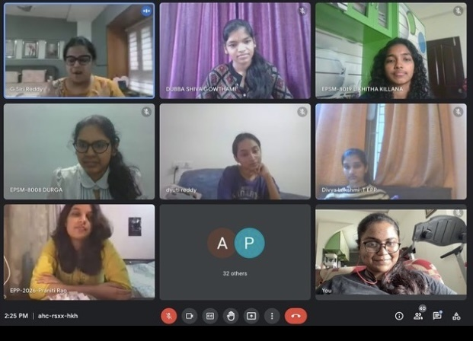

EVENT 2 – FIRE IGNITED
DATE – 11TH SEPTEMBER 2021
DAY – SATURDAY
PLATFORM – GOOGLE MEET

It was the first event of the year! This event was conducted in the form of two fun filled and greatly exciting competitions – ‘Just a minute’ (JAM session) and ‘Choose the incorrect option’. All Economics students from all three years were encouraged to participate. It was a very knowledgeable and productive event, with a lot of learning and interaction involved. The judges for the event were – Dr. Alice David (HoD Economics) and Dr K. Sirisha (Department of Economics). Winners and participants were awarded certificates. 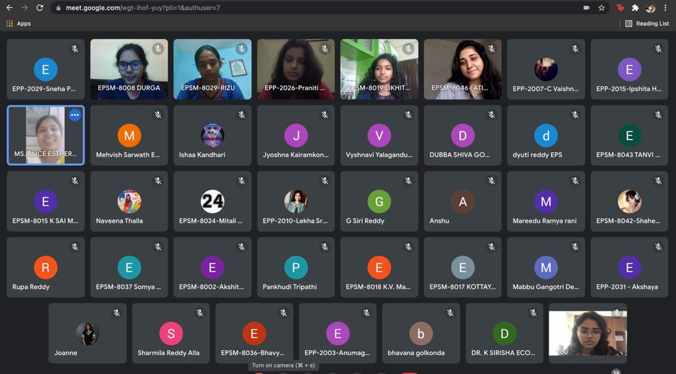

EVENT 3 – CAPACITY BUILDING PROGRAM
DATE – 30TH SEPTEMBER 2021
DAY – THURSDAY
VENUE- CAPITANIO HALL

This event was mostly carried out by our club coordinators – Dr. Alice and Dr. Sirisha.
It was conducted for the workers in the college. The concept of a bank account, pass book and deposit slip was explained to them. Slips and pens were given out to make it easier to understand and more practical. A video explanation was also provided. It was a very successful event.

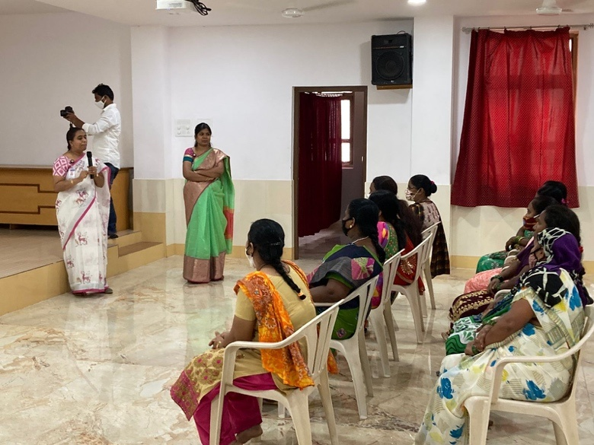

XPRESSIONS CONTRIBUTION

As a sub club of Xpressions, the club of the Arts Department of St Francis College for Women, FIRE club contributed greatly in the Yuvaflare fest, in the month of October, by being a part of the organizers of the ‘Samskruti Express’ event. In the month of December, for ‘Natale’, the Christmas Fest, we set up a Live Crib event, on 22nd December, 2021.
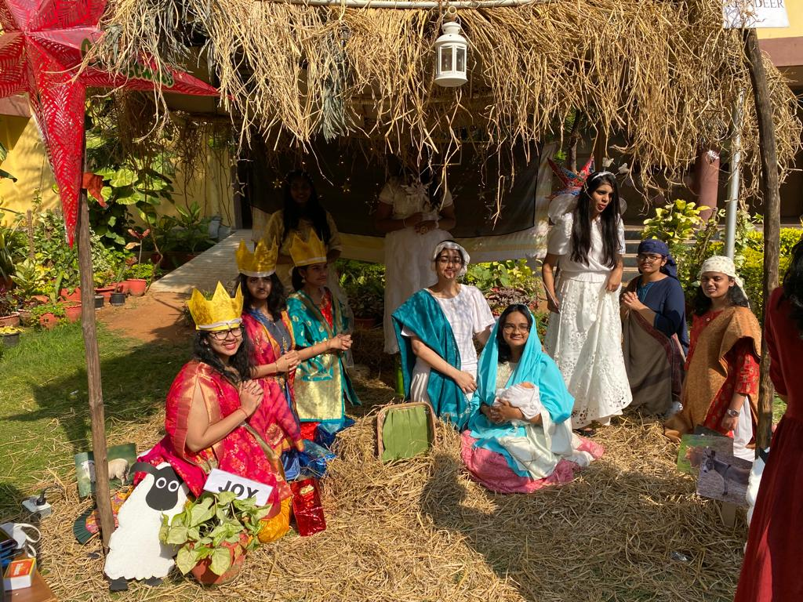

EVENT 4 – ONLINE VIDEO PRESENTATION
DATE – 15th OCTOBER 2021
DAY – FRIDAY
PLATOFRM – ONLINE

As a part of knowledge enrichment activity, the Economics students from the 2nd year participated in the Video Presentation Competition organized by the FIRE Club. The topic for the video presentation was to analyze the Macroeconomic Concepts of countries of the world. With active participation from the students, the event was filled with creative and enriching video submissions. Aimed rightly at creating awareness about economies around the world, the students expressed how the competition was very informative and helpful to them to study and understand the Economies of. various countries.

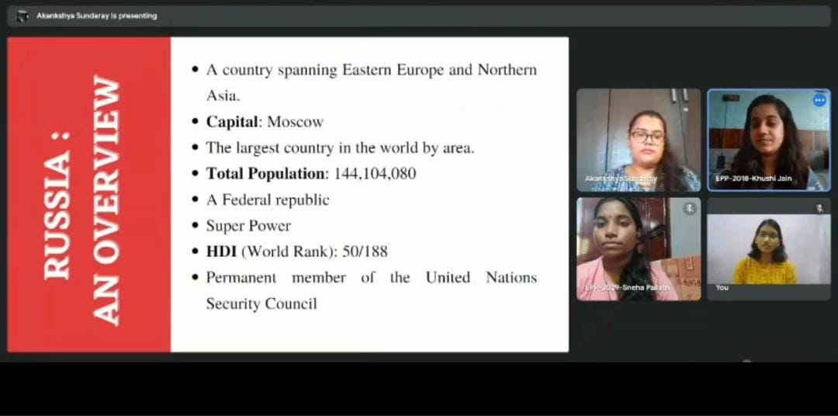

EVENT 5 – RADDHI
DATE – 7TH JANUARY 2022
DAY – FRIDAY
VENUE – CAMPUS

Raddhi was the very first offline event conducted by the club. It was a very significant event because of what it stands for. Students from all departments were asked to collect waste, which included paper, old cloth and scrap etc.
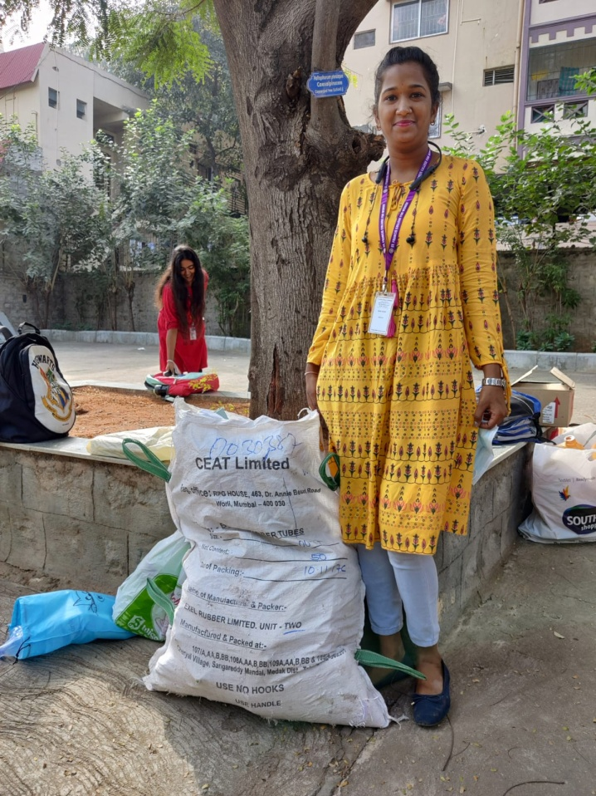

EVENT 6 – AZADI KA AMRUTH MAHOTSAV
DATE – 21ST JANUARY 2022
DAY – FRIDAY
PLATOFRM – ONLINE

This was another extremely exciting and fun filled event, conducted in the form of two competitions – ‘Mann ki Taarang’ (painting competition) and ‘Voice of Youth’ (Elocution). It was an Inter College event. Participants were asked to email their submissions and were judged accordingly. Cash prizes were given to the winners. The results were announced on Republic Day (26thJanuary 2022).
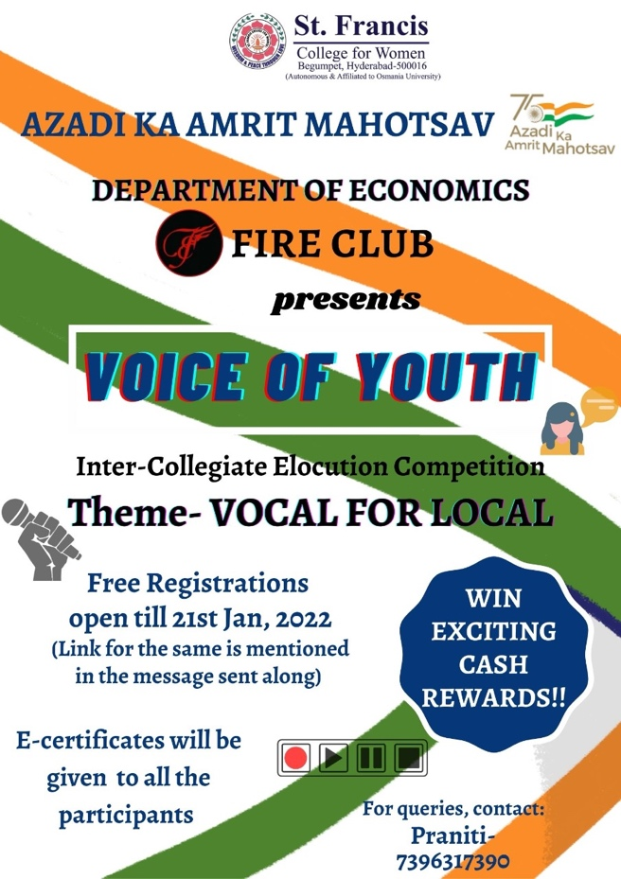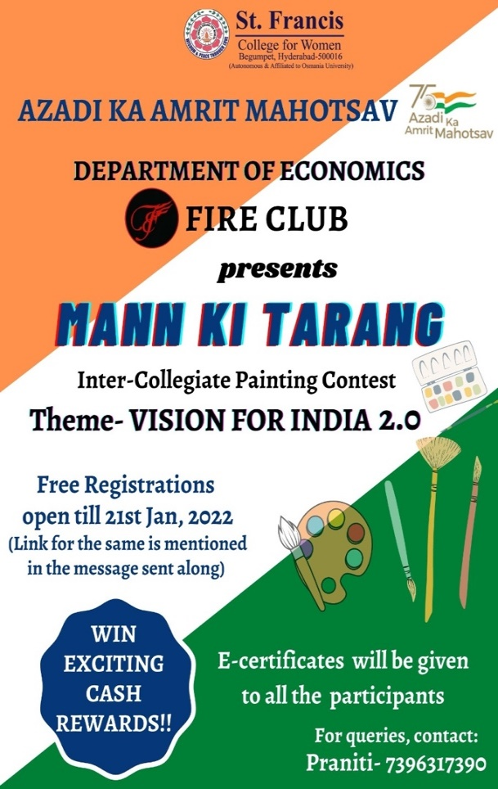

EVENT 7 – NATIONAL YOUNG ECONOMISTS CONCLAVE
DATE –3&4th MARCH 2022
PLATFORM – ONLINE

Students from all three years were eligible to take part in this event, conducted by Delhi University. They were required to choose an appropriate topic as a part of their research, following which, they were to submit their abstract for consideration. With the guidance and help of our teachers, 12 students from the first and second years were overjoyed on hearing their abstracts had been selected. They then had to submit their full research paper by 20th February, 2022. It truly was a unique and knowledgeable experience and the last requirement was to prepare a ppt for the presentation of their research.

